EXP NO 5: CREATE A SIMPLE CLOUD SOFTWARE APPLICATION FORLIBRARY BOOK RESERVATION SYSTEM FOR SIMATS LIBRARY USING ANY CLOUD SERVICE PROVIDER TO DEMONSTRATE SAAS
DATE: 30/09/2025
AIM:
To Create a simple cloud software application for Library book reservation system for
SIMATS library using any Cloud Service Provider to demonstrate SaaS
PROCEDURE:
step1: Go to zoho.com.
step 2: Log into the zoho.com.
step 3: Select one application step.
step4: Enter application name as library book reservation system.
step 5: Created new application as library book reservation system.
step 6: Select one form
step 7: The software has been created.
OUTPUT:
Form 1- Book Catalog Form
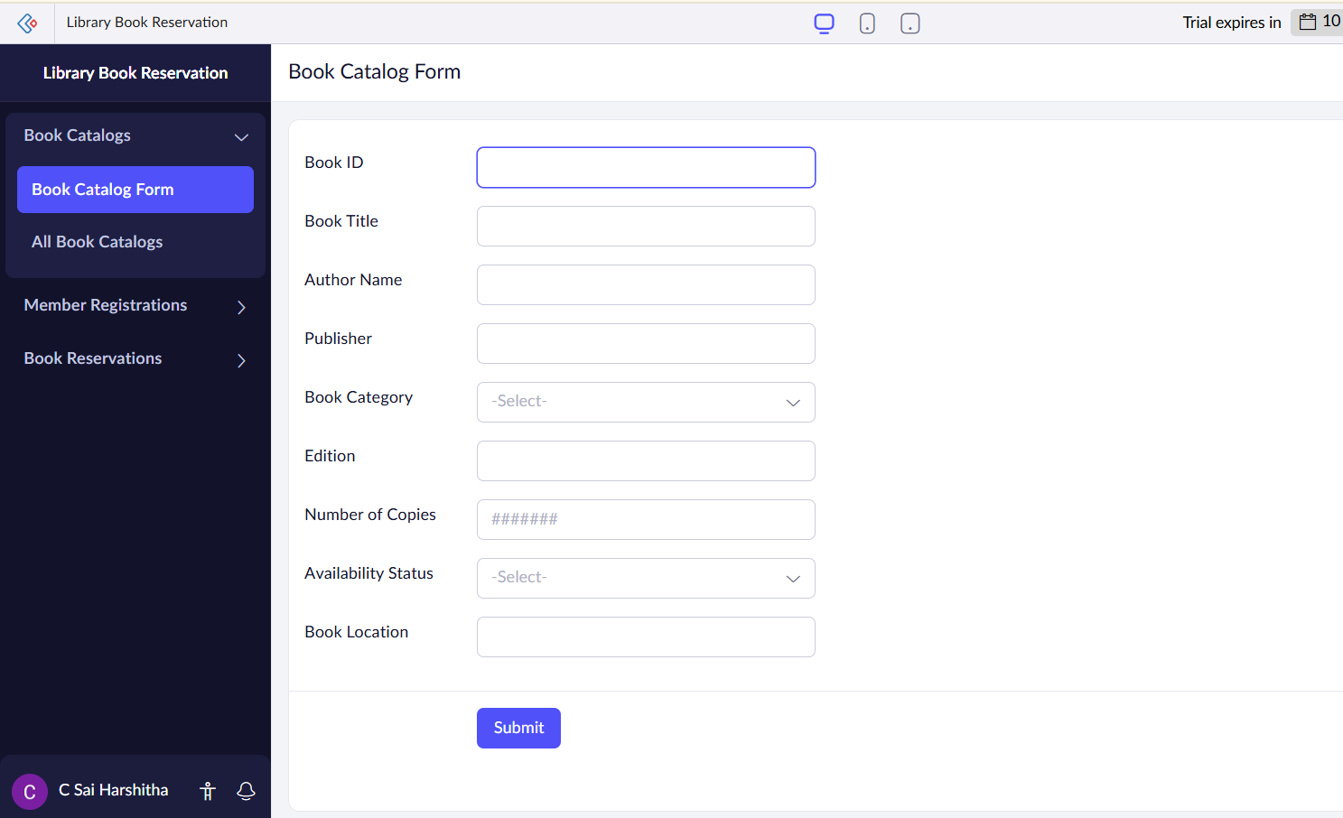
Form 2- Member Registration Form
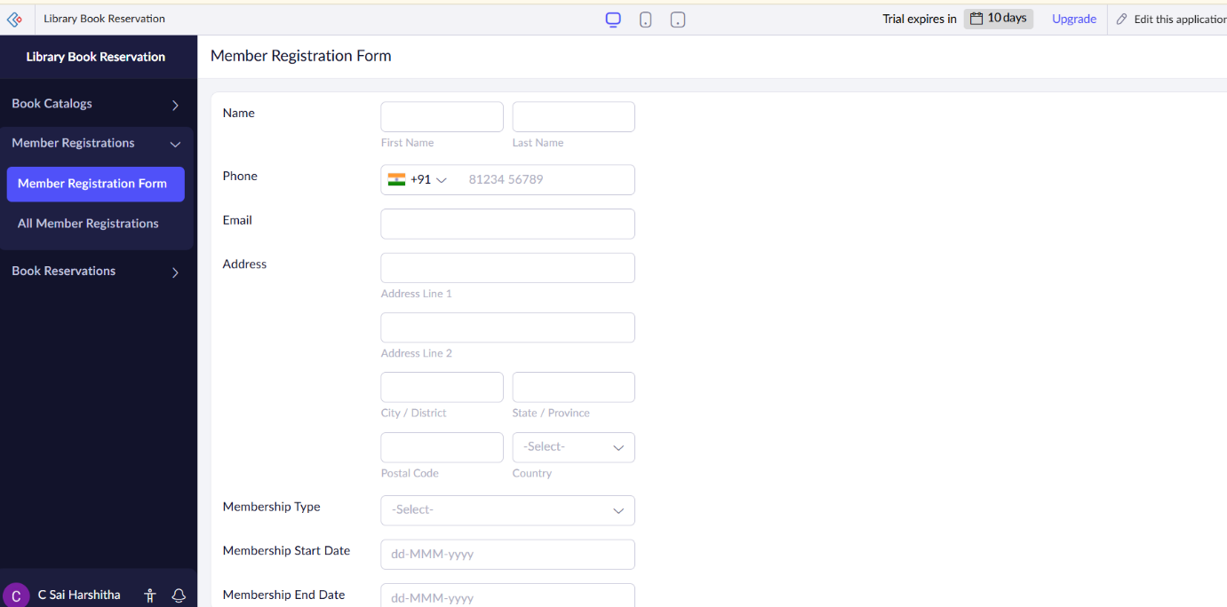

Form 3- Book Reservation Form
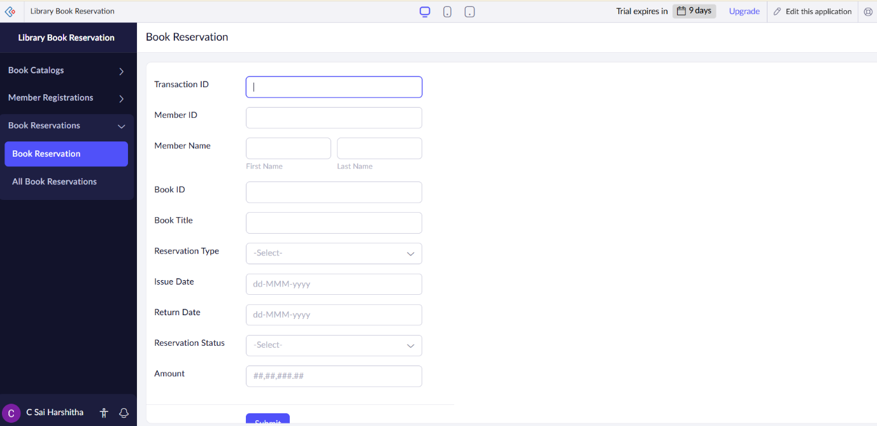

Form 1- Book Catalog Form
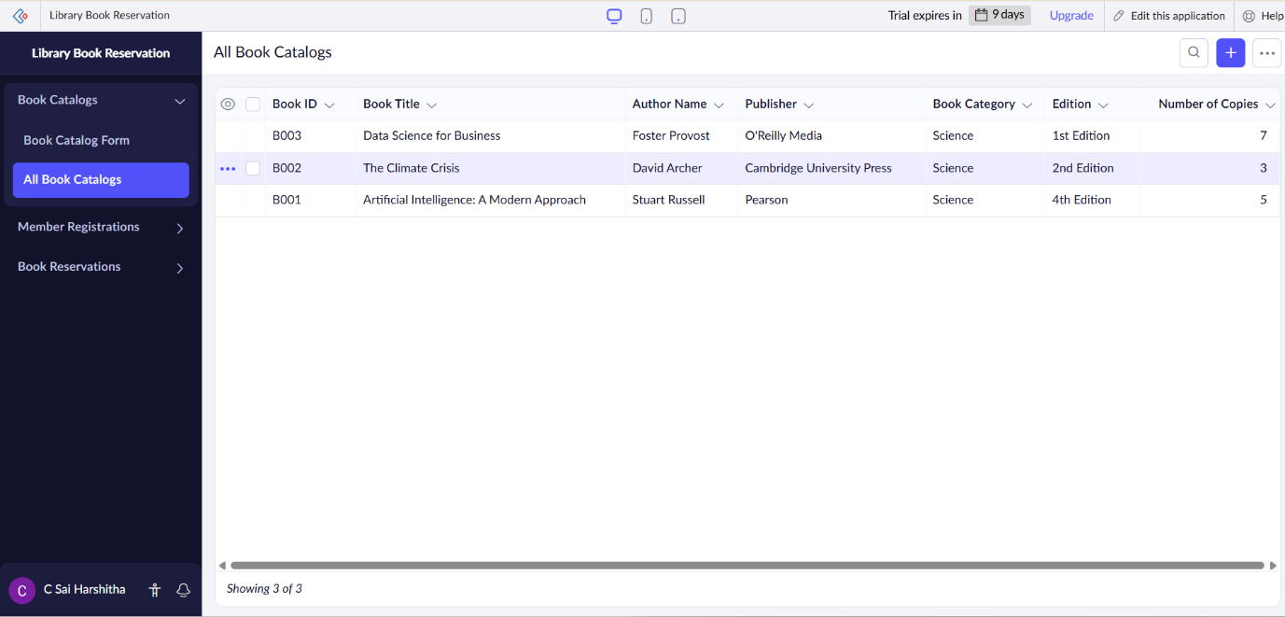
Form 2- Member Registration Form
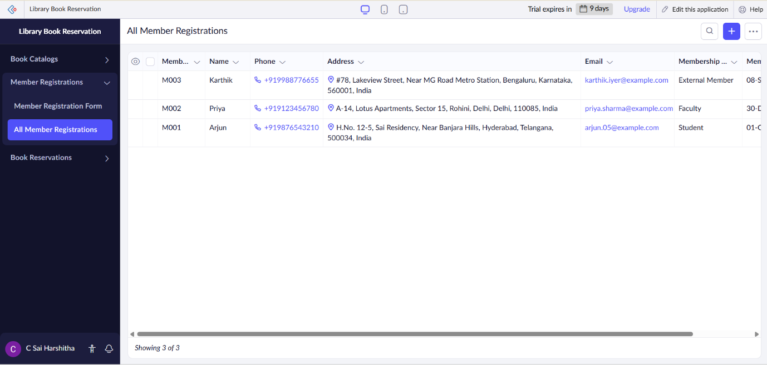

Form 3- Book Reservation Form
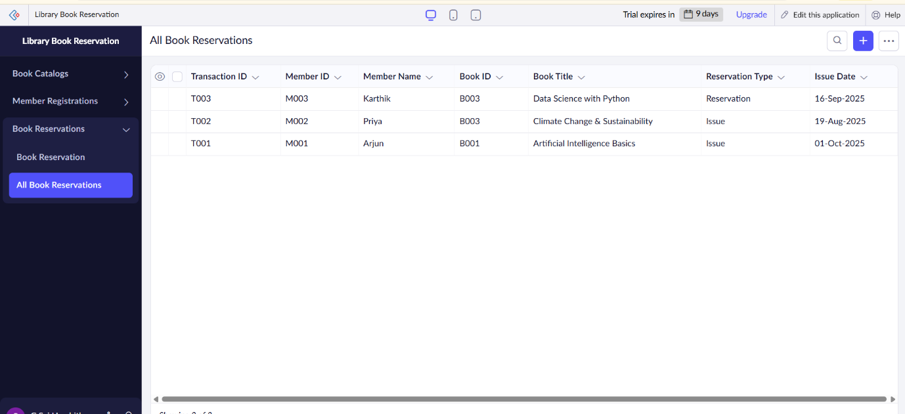

RESULT:
The Library Book Reservation System application was successfully created using Zoho Creator (Cloud SaaS platform) with the following forms:
- Book Catalog Form
- Member Registration Form
- Book Reservation Form
This demonstrates SaaS, as customers can register, view available cars, make bookings, and check their booking status entirely online without installing any software.

